The Biomolecules
The student is expected to compare the structures and functions of different types of biomolecules, including carbohydrates, lipids, proteins, and nucleic acids.

Carbohydrates, lipids, proteins and nucleic acids are organic compounds. This means that all of these compounds are built around carbon atoms, and they all contain at least one chemical bond between carbon and hydrogen (C-H).
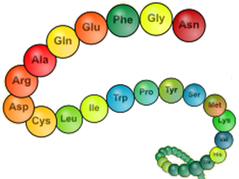
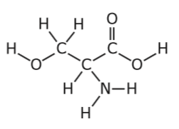
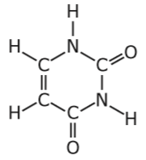
Organic Compounds

Polymer

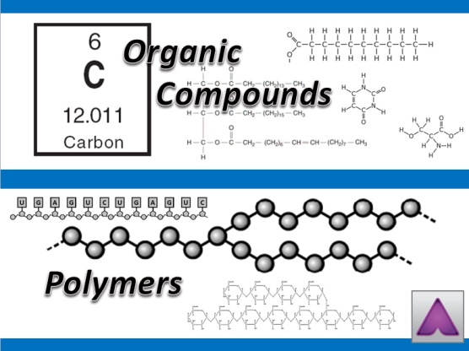
Carbohydrates, lipids, proteins and nucleic acids are also considered large macromolecules. Three of these classes (carbohydrates, proteins and nucleic acids) are polymers created through the polymerization of smaller subunits called monomers. Polymers can be thought of as chemical chains, and monomers are like the links in the chain. Carbohydrates are a polymer of simple sugars, proteins are polymers of amino acids, and nucleic acids are polymers of nucleotides.

Carbohydrates
Carbohydrates are macromolecules which contain only carbon, hydrogen and oxygen. Carbohydrates are also known as saccharides. Monosaccharides and disaccharides are commonly referred to as sugars. The names of these sugars end with the suffix –ose as in the names glucose, fructose, ribose and lactose.
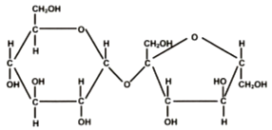

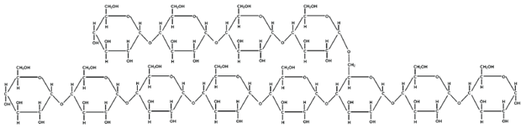
Disaccharide
Polysaccharide
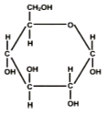

Monosaccharide

Carbohydrates are commonly used as an energy source. Plants produce simple sugars like the monosaccharide glucose during photosynthesis. Simple sugars can then be used to create complex carbohydrates. If the polymer contains between three and nine sugars, then it is called an oligosaccharide. Polymers that contain more than nine sugars are called polysaccharides. Polysaccharides can be used to store large amounts of energy inside living cells. Plants store energy in the form of the complex carbohydrate starch. Potatoes, rice and wheat contain large amounts of starch. Animals often store energy in the form of the complex carbohydrate glycogen. Glycogen is primarily made in the liver and muscles of animals. Polysaccharides are also used to make rigid cell walls in plants and fungi. Plants cell walls are made of the polysaccharide cellulose while fungal cell walls are made of the polysaccharide chitin.
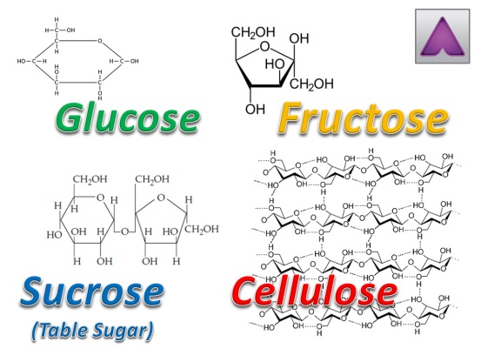
Lipids
Lipids are a group of organic molecules that includes triglycerides, waxes, steroids, and phospholipids. Triglycerides are commonly called fats, and they are made of a glycerol molecule bonded to three fatty acids. Lipids are nonpolar, hydrophobic molecules. This means that they do not mix with water. Because lipids are nonpolar and repel water, plants use waxes to control the evaporation of water from their leaves.
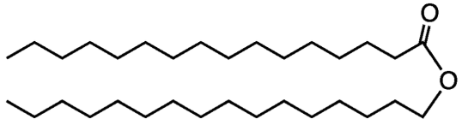
Wax

Triglyceride
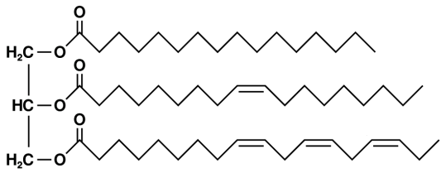
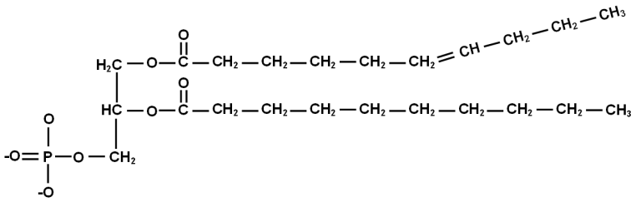

Phospholipid

Phospholipids are the main component of cell membranes. Phospholipids have a hydrophilic head made from a phosphate group which is attracted to water. This allows the cell membrane to interact with the water found on the inside and outside of the cell. The long hydrophobic tails prevent most molecules that are polar or have a charge from freely entering or leaving a cell.

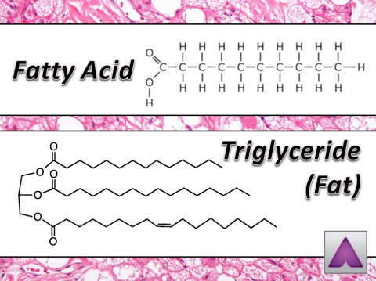
Triglycerides (fats) are also used to store large amounts of energy in the adipose tissue of animals, and fats are more efficient at storing energy than carbohydrates. Adipose tissue, also called fat tissue, provides a cushioning layer beneath the skin which can help protect internal organs. Fat tissue also provides the body with insulation against cold. Animals that live in cold climates often have thick layers of adipose tissue called blubber which prevents heat loss.
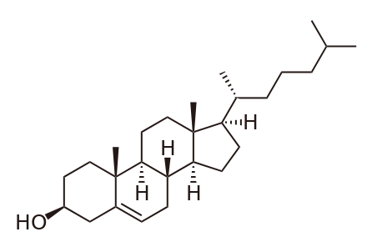
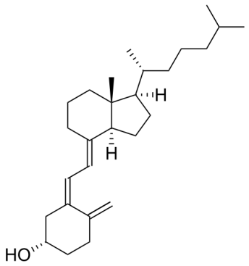
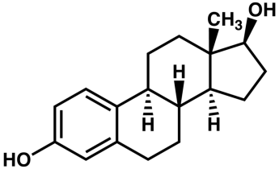
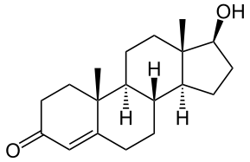
Cholesterol
Vitamin D
Estradiol
Testosterone

Another group of lipids is made up of compounds called steroids. All steroid molecules contain several rings of carbon joined together, and they serve a variety of functions in living things. Some steroids, like testosterone and estradiol, are hormones that help control metabolism. Vitamin D helps animals absorb vital nutrients such as calcium, iron and phosphate, and cholesterol is a vital component of animal cell membranes. Cholesterol helps maintain the structure of cell membranes and increases their fluidity.

Proteins
Proteins are chains of amino acids that are held together by peptide bonds. Because of this, amino acid chains are also referred to as polypeptides. There are 20 commonly occurring amino acids which can be placed together into any sequence to create proteins that are hundreds of amino acids long. Proteins perform a wide variety of functions in the cell and catalyze all of a cell’s chemical reactions.
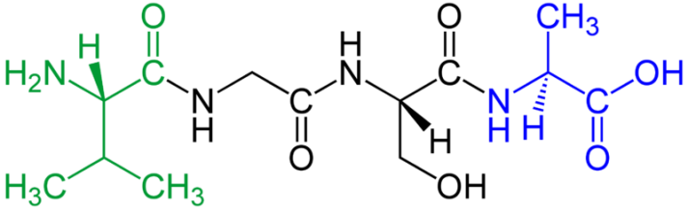
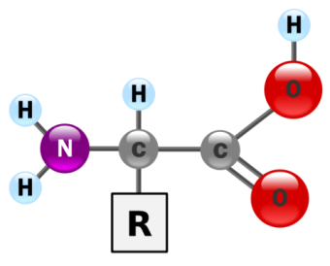
Amino Acid

Polypeptide

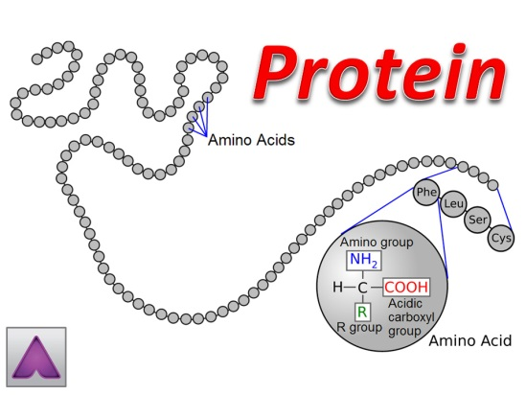
A specific type of protein called enzymes is responsible for catalyzing the chemical reactions in the cell. This means that the enzymes speed up the chemical reactions. Fibrous proteins are the main components of the cell’s cytoskeleton which gives the cell its structure. Proteins are also found in cell membranes, and these proteins receive signals from the cell’s environment and allow molecules to enter and leave the cell that cannot go directly through the phospholipid bilayer.

The instructions for making proteins are found in the genetic material of the cell. Proteins are made according to the genetic code, and each amino acid is translated from a specific sequence of nucleotides found in the DNA.

Nucleic Acids
Nucleic acids are macromolecules that carry the genetic information in all forms of life. Deoxyribonucleic acid (DNA) and ribonucleic acid (RNA) are the two main types of nucleic acids. Nucleic acids are large polymers of nucleotides, and each individual nucleotide contains three main parts: a phosphate group, a sugar, and a nitrogen base. If the sugar is deoxyribose, then the nucleic acid will be DNA. If the sugar is ribose, then the nucleic acid will be RNA.
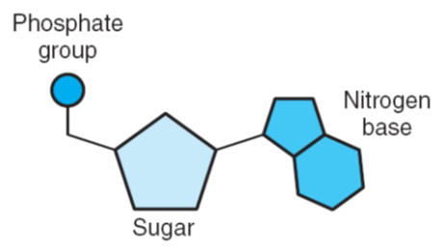
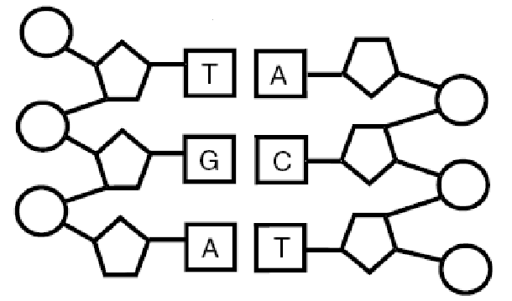
Deoxyribonucleic Acid
(DNA)
Nucleotide

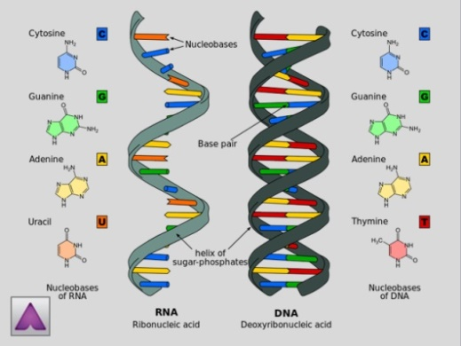
The sugar and phosphate group of each nucleotide makes a sugar-phosphate backbone that gives the nucleic acid its shape and structure. It is the nitrogen bases that carry the genetic information. The nitrogen bases found in nucleic acids are cytosine (C), guanine (G), adenine (A), thymine (T), and uracil (U). Thymine is only found in DNA, and uracil is only found in RNA molecules.

Nucleic acids are the genetic material that contains the blueprints for all living things. The sequence of nucleotides in the nucleic acid contains the instructions for making all of the cell’s proteins. Each sequence of three nucleotides is known as a codon, and each codon encodes for a specific amino acid in a protein.

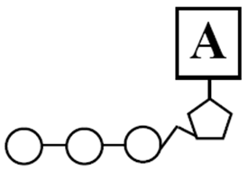
Adenosine triphosphate (ATP) is the common source of cellular energy used within cells. The energy found in carbohydrates and lipids is converted into ATP by cells. This energy can then be used to drive all of the chemical reactions in a cell. ATP is a nucleotide that contains three phosphate groups instead of just one.
ATP

